**Data-Driven Decision   
Making in SQL**

**Chapter1&2**

**Introduction to Data Driven Decision Making/ Simple SQl queries**

* Business insights from data
* OLAP extensions for business intelligence
  + CUBE, ROLLUP and GROUPING SETS (Business Intelligence tools)

* Find KPI

Review:

* AND, Oro
  + COUNT(column_name) ignores NULL.
  + COUNT(*) includes all rows, regardless of NULL.
  + COUNT(DISTINCT column_name) ignores NULL and counts unique values.

**Chapter3**

**Advamced SQl queries**

**Nested Query**

* Select block in WHERE or HAVING clauses
* Inner query returns single or multiple values
* Use result from inner query to select specific rows in another query

* A **correlated query** is a type of subquery where the inner query depends on the outer query for its values. This means the inner query is executed **repeatedly**, once for each row of the outer query.

* **UNION and INTERSECT functions**

* The same columns should always be selected.

* The same columns should always be selected.

**Chapter4**

**OLAP (Analytical processing)**

Business Intelligence – summarize and visualize data

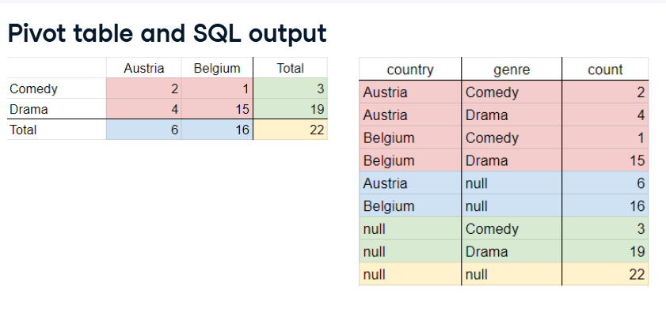

**CUBE operator:**

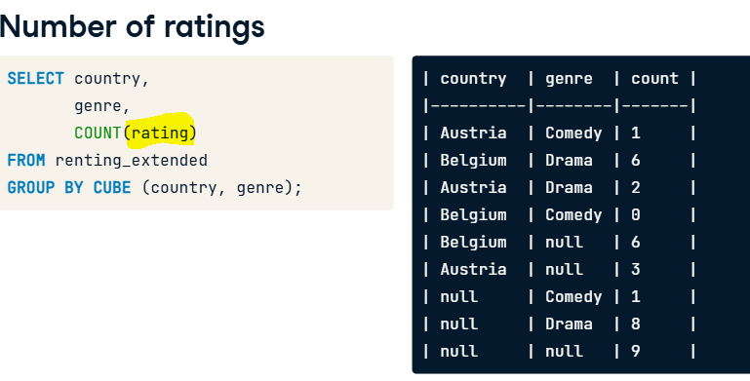

**ROLLUP 🡪 Improve the execution of OLAP**

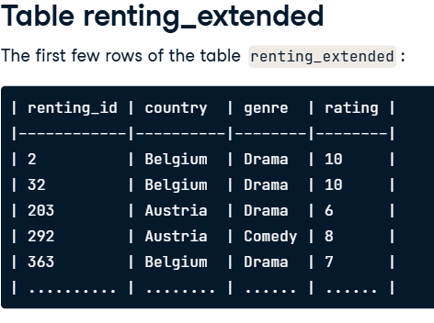

* For the second attribution, it is not reported separately!

* For the first attribution, it is not reported separately!

**GROUPINS SETS 🡪 The most flexible operator**

**Query 1: Using GROUP BY GROUPING SETS(nationality, gender)**

sql

Copy code

SELECT nationality, gender, COUNT(*)

FROM actors

GROUP BY GROUPING SETS(nationality, gender);

**How GROUPING SETS(nationality, gender) Works:**

It creates **two grouping combinations**:

1. Group by nationality (ignoring gender)
2. Group by gender (ignoring nationality)
3. Grand total (implicit in the result)

**Result of Query 1:**

| **nationality** | **gender** | **COUNT(*)** |
| --- | --- | --- |
| USA | NULL | 2 |
| Canada | NULL | 1 |
| NULL | Male | 2 |
| NULL | Female | 1 |
| NULL | NULL | 3 |

**Query 2: Using GROUP BY CUBE(nationality, gender)**

sql

Copy code

SELECT nationality, gender, COUNT(*)

FROM actors

GROUP BY CUBE(nationality, gender);

**How CUBE(nationality, gender) Works:**

It creates **all possible combinations of groupings**, which includes:

1. Group by both nationality and gender
2. Group by nationality only (ignoring gender)
3. Group by gender only (ignoring nationality)
4. The grand total

**Result of Query 2:**

| **nationality** | **gender** | **COUNT(*)** |
| --- | --- | --- |
| USA | Male | 1 |
| USA | Female | 1 |
| Canada | Male | 1 |
| USA | NULL | 2 |
| Canada | NULL | 1 |
| NULL | Male | 2 |
| NULL | Female | 1 |
| NULL | NULL | 3 |



